Adding log file



Making a log directory



Adding another log file inside made directory



Checking git status

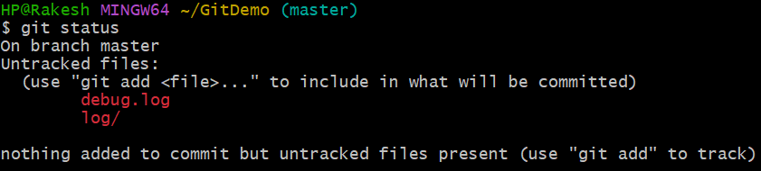

Making .gitignore



Adding .log files and /log inside .gitignore in notepad++

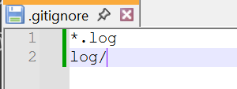

Checking working of .gitignore

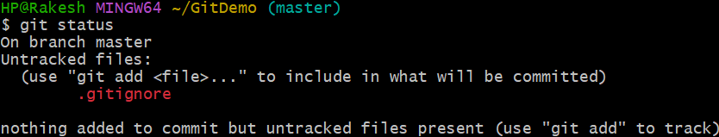

Adding .gitignore to repository



Committing .gitignore

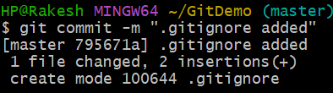

Pushing .gitignore to repository

